SPECIFICS OF LABOUR MARKET OF UNIVERSITY TEACHERS
Anna Barwińska-Małajowicz, Miroslava Knapková, Paweł Walawender

Introduction

This text is an output from the online workshop organized by the Institute of Economics and Finance, University of Rzeszów, Rzeszów, Poland, as part of the IVF project no. 22110433 „Does well-being matter? Higher education teachers during Covid-19 pandemic“. The workshop took place on 22nd October 2021, through the MS TEAMS platform. This text is the second one from a set of texts within the project. Its main goal is to present the main ideas that were presented at the workshop, focusing mainly on the specifics of the labour market of university teachers (to collect the basic knowledge about the university teachers work, which will allow to prepare appropriate list of specific activities of the university teachers for the questionnaire collection of the data).

Polish labour market – general notes
The concept of the labour market is complicated. It can be understood through the prism of various sciences such as economics, sociology, management science. The labour market (as defined by the classical definition used in economics) is the type of market in which labour is the object of exchange between buyer and seller. In the case of the labour market, the buyer is the employer offering employment, and the seller is the employee receiving a specific remuneration for his work. In this chapter, the basic information about the labour market in Poland (from the general point of view) are summarized.

Polish Economy
Polish GDP has grown almost continuously since 1990. The exception was 2008 and the last two years. This was due to the global crisis of 2008 and the Pandemic COVID-19 (Fig. 1).

Figure 1 Poland GDP Per Capita 1990-2021 (US $)
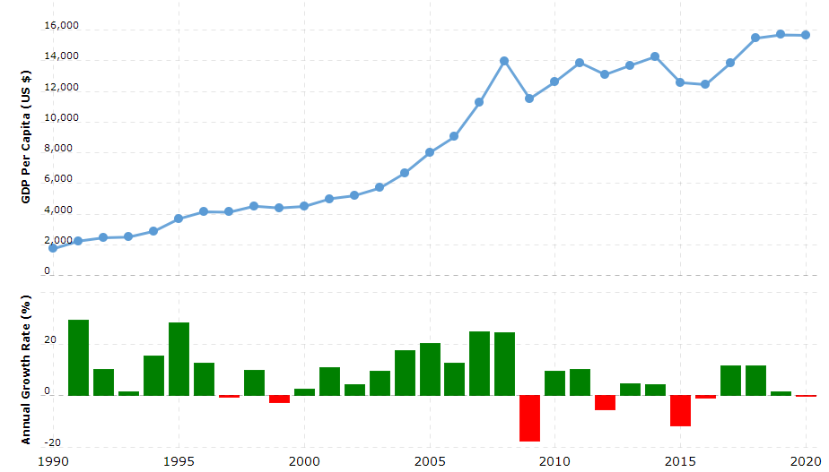
Source: https://www.macrotrends.net

Poland is one of the countries with low GDP per capita. It is worth noting, however, that in 1990 it belonged to the countries of the Eastern Bloc with one of the lowest GDP ratios (Fig. 2). Currently, for example, Hungary is behind Poland, which was quite significantly ahead of Poland in development.

Figure 2 Real GDP per capita for selected European countries in 2020 (Euro)

Source: Personal study based on the data of Eurostat

Wages have been steadily rising for several years (Fig. 3).

Figure 3 Wages and salaries
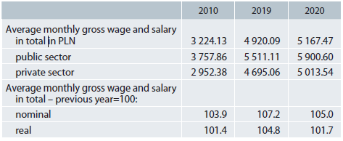
Source: Poland in Figures, 2021, Central Statistical Office

Over the past few years, the increase in wages has been faster than the increase in retirement (Fig. 4).

Figure 4 Indices of average monthly real gross wages and salaries and retirement and other pensions
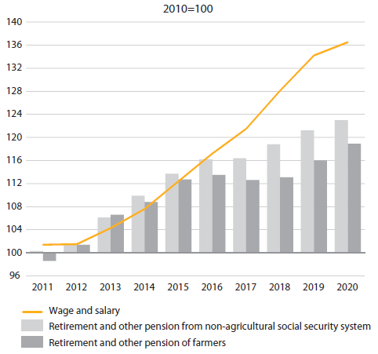
Source: Poland in Figures, 2021, Central Statistical Office

Territorial differentiation of development
The labour market in Poland is very diverse. This diversification is influenced by the economic condition of the regions. The least economically developed part of Poland is generally its eastern part. You can see it on this slide, where GDP per capita in individual provinces is presented (Fig. 5).

Figure 5 Gross Domestic Product per capita in 2019 (current prices)
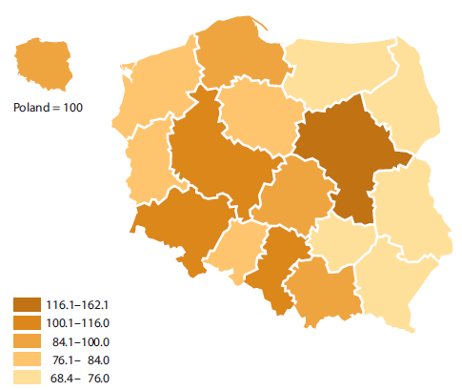
Source: Poland in Figures, 2021, Central Statistical Office

Demography
The Polish labour market is influenced by the demographic factor. As in other European countries, the problem is the aging of the population (Fig. 6). Forecasts for the future is that the percentage of people in post-working age will increase significantly, while the percentage of people in pre-working age will decrease.

Figure 6 Population by economic age groups (as of 31st December)
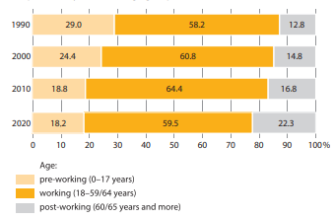
Source: Poland in Figures, 2021, Central Statistical Office

The Polish labour market during the COVID-19 pandemic

Figure 7 Average employment in the enterprise sector in Poland (January 2020-March 2021)

Source: Personal study based on the Statistics Poland data

The first months (March, April 2020) of the pandemic in Poland were marked by a decline in production, employment, wages and pessimism in terms of the economic situation. The following months brought an improvement in moods, an increase in employment and an increase in average wages (this concerned mainly the corporate sector). From the beginning of September 2020, the second wave of the COVID-19 epidemic swept through Poland, which, although much stronger (and more tragic) than the first, did not bring as many unfavourable changes in the economy as it did during the first "epidemic shock". A year after the announcement of the first epidemiological restrictions, Poland experienced the effects of the so-called third wave of the epidemic. Due to the growing number of infections in Poland, new restrictions were ordered. We are currently in the "fourth wave: a pandemic." Referring to the year of the pandemic in Poland, on the basis of preliminary GUS data and research results, it can be concluded that the effects of the COVID-19 crisis in Poland in relation to the labour market seem to be less severe than initially estimated.

Polish labour market during the industrial revolutions (particularly fourth industrial revolution (Industry 4.0))
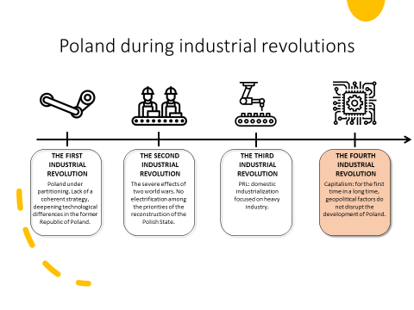

For the first time, Poland has a chance to participate in the technological revolution without delays caused by historical events. The fourth industrial revolution changes the labor market.
Research on the level of automation in Polish production plants proves that for the managers of Polish factories, the challenges of the third industrial revolution related to microelectronic technologies remain relevant to a large extent. An analysis of the degree of preparation of the Polish industry for the implementation of the Industry 4.0 concept, included in the ASTOR report, shows that:
- only 15% of factories in Poland are fully automated and 76% partially automated.
- Only 6% of Polish enterprises introduced Industry 4.0.
- The "Digital Poland„ report prepared by McKinsey indicated a significantly lower degree of digitization of Poland in relation to the United States and Western Europe.
- Poland's "digitization index" is 34% lower than in Western Europe.
- Additionally, McKinsey points out that the "digitization gaps" in relation to Western Europe in economic sectors such as "advanced industrial production" and "simple industrial production" are respectively: 45% and 78%.
Research on the level of automation in Polish production plants demonstrates that only 15% of factories are fully automated, and as many as 76% indicate partial automation.
According to the International Robotics Federation, the robotization density in Poland (the number of industrial robots per 10,000 employees) is 46 (Germany - 364, Slovakia -169, Czech Republic - 147, Hungary - 106, Romania - 25, the world average is 113)

Specifics of the labour market of university teachers in Poland
The teacher... is the guide and leader, the helmsman of the boat.
However, the energy that drives that boat must come from the learners.
Taylor MacKenzie

The teacher is a kind of slave who is perpetually out of time.
Lucy Maud Montgomery

Economic and social changes generate new challenges on the labour market for teachers in every country. The functioning of the teacher labour market determines, for a given school system, the number and characteristics of teachers, their distribution across schools, and the prevailing employment conditions, including the wage structure. Poland has recently witnessed significant changes in factors that were identified in literature as crucial to the situation of teachers on the labour market, such as systemic reforms, demographic trends, the overall situation on the labour market and occupational prestige.

Work and professional development of an academic teacher in the assembly. administrative and legal regulations.

In the Polish Classification of Occupations and Specialities, academic teacher - occupational group: „specialists” (specialists of teaching and educator), number 2310, (fields of science numbers: 231001-231021 i 231090)1. The professions that require a high level of professional knowledge, skills and experience in technical, natural, social, humanistic and related sciences.
Academic teacher (Art. 114 of the Law on Higher Education, 20 July 2018) is employed in the following staff groups: teacher, researcher, researcher and teacher (academics). Working at the university in common terms is a full-time job, but definitely not ending job. Like studying, which does not begin and end on the classes it’s continues continuously, the work of a researcher-teacher definitely goes beyond the standard working hours and time spent on the university.
Under the Act 2.0, to become an academic staff member:
- person must have the qualifications specified in the law and the statute;
- cannot be punished with a disciplinary penalty (get fired from work in a university with a ban on work in universities for a period from 6 months to 5 years; suing of the right to be academic teacher for a period of 10 years);
- must have full legal capacity;
- must have a full public rights;
- must not have been convicted of an intentional crime or an intentional fiscal crime (this does not concern only to criminal of copyright, e.g. plagiarism).
A career is based on following a path of advancement (advancement proceedings):
- proceedings leading to the Ph degree ,
- proceedings leading to the degree of associate professor (doktor habilitowany),
- proceedings leading to full professor degree.
Act 2.0 includes a new regulations for promotion proceedings. Promotion schemes are in the POL-on system.

PhD Degree
- doctoral schools, doctoral seminars (extramural mode)
- doctoral thesis
- preparation of doctoral dissertation, doctoral examinations, public presentation of the doctoral thesis

Associate professor degree
Specific or artistic achievements achieved after the PhD degree, presenting the author's significant contribution to the development of a specific scientific or artistic discipline and presenting significant research or artistic activity. The procedure for the conferment of the academic degree of associate professor degree shall be initiated at the request of person who applies for the conferment of the academic degree of associate professor.

Professor
The title of professor shall be conferred by the President of the Republic of Poland. This title may be awarded to a person who: has obtained a degree of habilitated doctor; has scientific or artistic achievements, which fall far beyond the requirements for the candidates applying for the degree of habilitated doctor; has an excellent didactic record, among other things, within the scope of training of academic or artistic staff.

The work of an academic teacher - the essence and specificity

The specificity of the academic teacher's work cannot be put into rigid frames, some of its aspects escape definitions and characteristics. There is a space between the academic teacher and the researcher, which is filled not only by the expectations of the academics, but also by students, employers, society as well as (and perhaps most important) by their goals, responsibilities, needs, concerns, and problems.
It is not only a scientist - researcher and teacher - organizer, manager and controller of the didactic process, but also an „accountant”, mentor, supervisor of students (of the year, specialization, scientific circle), tutor, negotiator, guide, and even a therapist and educator.
The polysemantic nature of the academic teacher profession and multitasking inscribed
in its nature.

Professional competences of an academic teacher

In the context of a specific subject of study, these are subject - related competences:
- the system of key competences,
- praxeological – the effectiveness of the academic teacher in planning, organizing, implementing, controlling and evaluating the student learning process,
- communicative - effective language communication of an academic teacher in the educational process and in interactions with students,
- interacting - the proficiency of the academic teacher's integration activities, e.g. the ability to establish and maintain contact with students,
- creative- innovation and non-standard activities of an academic teacher,
- IT - efficient use of modern information sources,
- moral - knowledge of own ethical obligations towards the subjects of educator – students.
(These are the preferred features of an academic teacher in students opinion: research - University of Rzeszow, Faculty of Pedagogy (260 students).
The results of the survey: ranking of the level of importance of individual characteristics of academic teachers of the Pedagogy Faculty at University of Rzeszow. The most preferred qualities according to the students are considered (in brackets - place in the ranking):
- having practical knowledge (1),
- respecting student rights (2),
- being honest (3),
- respecting others' reasons and opinions (4),
- being well-mannered (5),
- being communicative (6),
- being able to admit mistakes (7),
- being intelligent (8),
- being objective (9),
- being kind (10).
Less important characteristics are:
- Participation in international scientific cooperation (conferences),
- using of foreign languages,
- good appearance,
- modesty,
- being demanding,
- straightforwardness.

The labour market of academic teachers - selected information and statistic data

The market for teachers functions like any other labour markets, with schools acting as employers of teachers. The labour market for teachers is worthy of attention not only by its size but also because of its effect on children’s human capital acquisition and ultimately voter satisfaction. The teacher market, like some other public sector occupations, such as health professional, is peculiar since the State has both monopoly power in the provision of credentials and nearly monopsony power in the recruitment of teachers.

Table 1. Number of academic teachers in Poland (2010-2018)

 | 2010 | 2011 | 2012 | 2013 | 2014 | 2015 | 2016 | 2017 | 2018
Poland | 101 627 | 100 808 | 100 738 | 98 497.3 | 96 534.2 | 95 918.5 | 95 433.8 | 94 707.4 | 93 138.8
podkarpackieVoivodeship | 3 237.0 | 3 264.0 | 3 273.0 | 3 096.1 | 3 023.7 | 3 027.5 | 3 019.2 | 3 071.9 | 2 987.1
mazowieckieVoivodeship  (max) | 17 192.0 | 17 067.0 | 17 785.0 | 17 960.4 | 17 482.1 | 17 427.5 | 17 125.0 | 17 110.9 | 17 044.8
Source: own study based on Banku Danych Lokalnych, Główny Urząd Statystyczny Warszawa.

Number of teachers: Mazowieckie Voivodeship, Małopolskie Voivodeship (12712.4), Śląskie Voivodeship (8241.6), Wielkopolskie Voivodeship (8919.6), Dolnośląskie Voivodeship (8479.1). All Voivodeship - a clear decreasing tendency. The percentage of academic teachers in Podkarpackie voivodship in the total number of academic teachers = 3,2%.
According to the POL-on register, 373 universities operated in Poland in the academic year 2019/20. The universities employed 93.1 thousand academic teachers, including 43.7 thousand women. There were nearly 13 students per 1 teacher. For comparison – number of teachers in kindergartens and lower-level schools – 513 868 people.

Table 2. Academic teachers by type of institution in the higher education and science system (full-time), 2019/2020
ACADEMIC TEACHERS
Total | Professors | Associate professor | PhD | Assistants | other
88675 | 24662 | 190 | 38458 | 12072 | 13293
women  41654 | 8102 | 57 | 19011 | 6784 | 7700
Resource: own study based on: Szkolnictwo wyższe i jego finanse w 2019 r., Urząd Statystyczny w Gdańsku 2020.

Table 3. Academic teachers by type of institution in the higher education and science system (full-time) - PUBLIC UNIVERSITY, 2019/2020
PUBLIC UNIVERSITY
Total | Professors | Associate professor | PhD | Assistants | other
79212 | 22154 | 126 | 34818 | 10876 | 11238
Resource: own study based on: Szkolnictwo wyższe i jego finanse w 2019 r., Urząd Statystyczny w Gdańsku 2020.

Table 4. Academic teachers by type of institution in the higher education and science system (full-time) - NON-PUBLIC UNIVERSITY, 2019/2020
NON-PUBLIC UNIVERSITY
Total | Professors | Associate professor | PhD | Assistants | other
9463 | 2508 | 64 | 3640 | 1196 | 2055
Resource: own study based on: Szkolnictwo wyższe i jego finanse w 2019 r., Urząd Statystyczny w Gdańsku 2020.

Declining trend in the number of working academics - reason: declining number of students (in 2018 at public universities - 1.2 million students; 10 years ago - 1.8 million).
This is not a complete explanation - there are less students, but academics are overloaded with teaching.
Working at the university is no longer a dream - not only for financial reasons (in the market specialists can earn much more), but also because of unfavorable working conditions - „taking care of the points, colled punktoza (punctosis)”, poor culture of cooperation.
Decline of the number of young academics - according to Supreme Audit Office (NIK): inadequate motivational mechanisms for scientific development and fast attainment of subsequent scientific degrees as well as employing scientific staff mainly in connection with teaching work.

Summary

R. Barnett said, a typical feature of higher education institutions in recent times is the intertwining of the research university, entrepreneurial university and bureaucratic university models.
In such an understanding of the university, its size, quality and significance are not determined by the number of professors employed, research projects carried out, the number of research made or the number of well-educated graduates, but by the desire to work, cooperate and maintain contacts.
Change in the structure of work organization in higher education institutions - flexible structures are created, parallel to the existing organizational structure, realizing expert opinions and reports on the order of various organizations and institutions, providing consultations and preparing specialized research.
It is difficult to develop different area: scientific, teaching, organizational as well as to combine research and leadership skills.
Despite the need to combine these areas, the university should define a strategic dominant direction for the professional development of university teachers that it will support organizationally and leave freedom for self-study in other areas of development.
In the aspect of scientific work of an academic teacher (educator, researcher) is little known to the general public (the phrase: „You have so good, a lot of free time...”). A huge part of the tasks is carried out in so-called „free time” (holidays, weekends, public vacations), it is limited by specific deadlines (24/7 work system). Declining trend of applying for a job in the university. The work of an academic teacher - creative, time-consuming and responsible.

Specifics of university teachers‘ labour market (global and V4 perspective)
There are not many studies focusing on the labour market of university teachers. It is an opposite situation to labour market of graduates, or preparation during the university study for the active participation at the labour market.
We will focus on the university teachers ‘labour market based on the content analysis of the published studies, from 2004 till the present. Reason for starting with 2004 is the fact, that all V4 became members of the European Union in May 2004, what significantly also influenced the teachers labour market. Specifics of university teachers labour market are mostly those, which influence labour market equilibrium.

Research of teachers’ labour market within the Europe and world
Chevalier and Dolton (2004) published a study focusing on the labour market of teachers in England (however, teachers in general, not only university teachers). They pointed, that labour market of teachers is worthy of attention because of:
      - The size of teachers’ labour market
      - effect of teachers on children’s human capital acquisition
      - effect on voter satisfaction.
They also identified specifics of teachers’ labour market in England, as following:
- State has monopoly power in the provision of credentials,
- State has nearly monopsony power in the recruitment of teachers (public schools),
- teaching is a highly unionised occupation where salaries are settled on a nationally agreed pay scale,
- teaching is mostly a female occupation, which adds some further difficulties to the modelling of teacher’s supply.

The biggest problems on teachers’ labour market are the recurrent crises in the recruitment and especially the retention of teachers.

Bauder (2005) focused on segmentation of academia labour market in Canada. He found that academia is increasingly driven by economic forces, However, we see little evidence that the academic labour market is driven by a mysterious invisible hand of the market. He pointed to the following problems (eventually specifics) of academia labour market:
- faculty salaries declined relative to total expenditures of universities, from more than 31 percent in the late 1970s to roughly 19 percent in 2004,
- change of faculty-student ratio (in the 1992-1993 academic year there were on average only 18.8 full-time students for every full-time faculty member, eleven years later there were 23.7)
- the segmentation of the academic labour market is gendered (however, opposite situation than in V4 countries - data for 2003-2004 collected by CAUT indicate that across all disciplines, only 18.1 percent of full professors are female; non- professors’ 54.2 percent are women)
- qualification requirements are extremely high: usually an earned doctorate, or at least doctoral candidacy,
- academia serves as a symbolic economy, in which academic performance assumes a symbolic value that is worth little in other occupations,
- competition does not exist uniformly across the entire academic labour market,
Passaretta, Trivellato, and Triventi (2019) focused on the occupational outcomes of PhD graduates in Italy. They pointed to changes in academia regulation (mostly cuts to public funding, introduction of fixed-term positions for assistant professors) and the economic crisis. Their study summed up, that the academic reforms reduced the chances to work in academia more in soft rather than in hard academic disciplines.
Musselin, C. (2009) focused on the regulation of the academia in Germany, France, the USA. Beside other topics, his study points also to the specifics of division and allocation of work of academic staff. He suggests that:
- Academic activities are specific. They are neither strongly formalized nor standardized.
- Academic activities are closer to an “intellectual” craft, each “product” (a course, a paper, or a research project) being conducted from the beginning to the end by one person or by a small group frequently composed of a team leader and a few subordinates,
- the division of work is not formally structured
- the contrast in terms of division and allocation of work between the primary and the secondary labour markets is stronger than within each of them,
- contents as well as the scope of work of the less secure positions (secondary labour market) are most of the time focused on only one aspect of academic work (adjuncts for instance only have teaching assignments while post-docs are generally dedicated to research only),
What influences the division of work of permanent academia staff?
            - the status,
            - the institutional hierarchy
            - self-regulation
He also pointed to the features of academia labour market:
- co-existence of segmented academic labour-markets (primary labour markets on the one hand = permanent staff, rather stable academic positions; and secondary on the other = different types of time-limited positions are concerned: from doctoral students to research fellows, adjuncts or part-time teachers); - for example, In Germany for instance, non-professor positions are for a limited time, assistants depend on professors who recruit them, define their research programs and teaching duties and act as their employers
- limited methods of financing (in Germany, the introduction of merit-salaries is recent and before the 2002 act, there was no possibility for the universities to reward or sanction their staff. In France, some bonuses were introduced by the beginning of the 90s (but they are rather narrowly regulated and do not allow much leeway in each institution) and universities can decide for some promotions),
- academic work is controlled - assessment, control and reward of academic work are at the crossroads of three forms of regulation (the organisation, the market and the profession) - (professional control is now weaker while institutional control is on the increase), example of still existing professional control - control by peers relies partly on organised tests (épreuves) and partly on procedures (e.g. recruitment, submission of papers to a journal for review etc.)
- Affiliation to a collective entity – arising question: Are academia staff single players in a competitive market, members of a professional group or individuals committed to their institution? (The negotiation of material and human resources during the recruitment process implies a contract through which the institution provides professors with resources allowing them to develop their research while the professors in exchange agree to participate in the administration of the university and show institutional loyalty. The institution ‘bets’ on the professor and expects a return on investment.) Change in the nature of the links between universities and academics – and trends in employer–employee relationships – will affect not only academic identities but also practices, because it also transforms academic activities into academic work

Paye (2011) focused in on the teaching – research nexus in British universities. He pointed that There is limited knowledge on how and why certain individuals end up in teaching posts, others in research posts and others on more traditional posts, performing both. This significantly influenced university staff labour market.
Aluko (2009) analysed work-life balance of university teachers in Portugal. He pointed that “increasingly economistic and managerial ethos, which surrounds university life,” (Currie et al., 2000, p. 269), academic jobs have become more demanding in terms of effort, as well as time. With growing institutional demands and accountability and work intensification a 50 or 60 hours per week workload became the norm in many universities (Jacobs and Winslow, 2004).
Gill, (2016) pointed to another negative trends in the academia labour market in the US. They are:
- precariousness particularly, but not exclusively, for younger or „career early“ staff. As he stated, while, in the past, short-term contracts were largely limited to research positions and tied to specific, time-limited projects, today they also characterise teaching posts which are frequently offered on a one-year temporary basis at the bottom of the pay scale;
- intensification of academia work, and in some way also punishing intensification of work (event the staff work overtime, it is not officially recorded and valued);
- marked extensification across time and space - Work in today’s universities is, „academia without walls“. This is the outcome of multiple determinants but is facilitated by information and communication technologies that render it possible to be „always on“;

One of the most recent studies focuses on the permanent contracts and job satisfaction in academia, from the European countries’ perspective (Castellacci and Viñas-Bardolet, 2021). Authors pointed to the fact, that temporary contracts are increasingly used in academia, what is linked with a weak job security. They also raised an interesting question, whether the permanent contracts contribute to support researchers ‘well-being? To answer the question, they stressed following idea: „if the increasing use of temporary forms of employment will end up weakening job security and worsening career prospects for non-tenured academics, many of these may well decide to leave academia and get a job some-where else. If so, the public science system will progressively become a less attractive sector of employment for many young talents, and thus weaken its quality, performance and competitiveness in the longer run“.

Research/data linked to teachers’ labour market within V4 countries
There are not many relevant statistics focusing on the university teachers labour market in V4 countries. To get, at least rough, overview about the situation in V4 countries, we summarised data from the Survey on researchers in European Higher Education institutions (Luxembourg, 2017). The survey focused on a survey of researchers currently working in the EU (and EFTA) in higher education institutions (HEI) regarding their mobility patterns, career paths, employment and working conditions. For the study, a researcher is defined in accordance with the Frascati manual as “professionals engaged in the conception or creation of new knowledge, conducting research and improving or developing concepts, theories, models, techniques instrumentation, software or operational methods”. The research sample was identified by fulfilling following criteria:
- carrying out research OR
- supervising research OR
- improving or developing new products/processes/services OR
- supervising the improvement or development of new products/processes/services.
Following groups of fields of sciences were analysed:
- NATURAL: Natural Sciences and Engineering and Technology
- HEALTH: Medical and health sciences and Agricultural and veterinary sciences
- SOCIAL: Social Sciences and Humanities and the Arts
These four career stages were recognised:
R1: First Stage Researcher (up to the point of PhD),
R2: Recognised Researcher (PhD holders or equivalent who are not yet fully independent);
R3: Established Researcher (researchers who have developed a level of independence);
R4: Leading Researcher (researchers leading their research area or field.
In the following text, we present basic results of the study linked with V4 countries:
      - Gendered perspective – in Slovakia and Poland, higher shares of women participated in the survey than on average in the EU28 countries (we can just suggest, that more women work in HEI than men in Slovakia and Poland). Czech Republic is one of those countries with the largest negative change of women proportion in HEI from 2012 (-6.5%).
      - Income/ remuneration/ financial security - Financial security and remuneration is an important aspect of working conditions – in Slovakia, only 32 % and in Hungary only 34 % of researchers feel well or at least reasonably paid. In Slovakia, the share of researchers unsatisfied with their remuneration decreases with higher career stages.
The table 5 shows answers (paid only sufficiently or badly paid) in V4 countries, based on career stage.

Table 5 Sufficiently or badly paid researchers in V4 countries
Country | R1 | R2 | R3 | R4
Czech Republic | NA | 63.0% | 44.8% | 47.7%
Hungary | 74.8% | 57.8% | 63.7% | 68.9%
Poland | NA | 49.7% | 54.2% | 35.5%
Slovakia | 54.7% | 74.4% | 72.3% | 58.7%

      - Job security, pension plan and social security
The table 6 shows answers linked with Individual satisfaction with job and social security attributes in V4 countries.

Table 6 Share of researchers satisfied with their job security, pension plans and social security)
Country | Job Security | Pension Plan | Social Security
Czech Republic | 0.37 | 0.36 | 0.21
Hungary | 0.93 | 0.72 | 0.71
Poland | 0.30 | 0.32 | 0.25
Slovakia | 0.73 | 0.65 | 0.68
- The table illustrate the distance from the country with the highest share of satisfaction; 0 = country with highest share; 1 = country with lowest share
In Poland, HEI researchers are the most satisfied from V4 countries. On the other hand, researchers in Hungary are the least satisfied.

- Switching to another field of research during the career (as part of interdisciplinary mobility). Interdisciplinary mobility is perceived controversially – only about 70 % of those actively participating in interdisciplinary mobility considered it as positive for their career).

Table 7 Percentage of researchers switching to another field of research
Country | Percentage
Czech Republic | 27.9%
Hungary | 44%
Poland | 28.3%
Slovakia | 41:3%

Other data we processed based on the Eurostat databases. We provide information about the development of the ratio of students to academic staff, number of academic staff (divided by gender and by full-time and part-time contract).

Table 8 Students to academic staff ratio in V4 countries in 2013 – 2019 (in %)
TIME | 2013 | 2014 | 2015 | 2016 | 2017 | 2018 | 2019
European Union - 27 countries (from 2020) | : | 15,4  d | 15,4 d | 15,1  d | 15,3  d | : | :
Czechia | 21,9 | 22,3 | 23,3 | 18,9 | 18,4 | 15,0 | 16,8
Hungary | 14,8 | 15,1 | 14,6 | 13,7 | 12,1 | 11,5 | 11,4
Poland | 15,1 | 15,2 | 14,9 | 14,6 | 14,3 | 13,8 | 13,5
Slovakia | 13,8 | 13,7 | 13,0 | 15,1 | 11,9 | 11,4 | 11,3
Source: Own elaboration based on Eurostat data.

Table 9 Academic staff (tertiary education) in V4 countries in 2013 - 2019
TIME | 2013 | 2014 | 2015 | 2016 | 2017 | 2018 | 2019
European Union - 27 countries (from 2020) | : | 1 199 407  d | 1 274 685  d | : | : | : | :
Czechia | :d | :d | :d | :d | d | d | :d
Hungary | 23 674 | 21 778 | 21 045 | 21 705 | 24 119 | 25 184 | 25 174
Poland | 102 827 | 99 918 | 97 413 | :d | : | : | :
Slovakia | 12 832 | 12 798 | 12 767 | 12 425 | 12 204 | 12 101 | 12 004
Source: Own elaboration based on Eurostat data.

Table 10 Academic staff (tertiary education) – males in V4 countries in 2013 - 2019
TIME | 2013 | 2014 | 2015 | 2016 | 2017 | 2018 | 2019
European Union - 27 countries (from 2020) | : | 705 102  d | 746 393  d | : | : | : | :
Czechia
Hungary | 14 493 | 12 345 | 12 183 | 12 337 | 14 415 | 14 853 | 14 833
Poland | 57 486 | 55 726 | 54 161 | : | : | : | :
Slovakia | 7 098 | 7 058 | 6 973 | 6 753 | 6 619 | 6 511 | 6 414
Source: Own elaboration based on Eurostat data.

Table 11 Academic staff (tertiary education) – females in V4 countries in 2013 – 2019
TIME | 2013 | 2014 | 2015 | 2016 | 2017 | 2018 | 2019
European Union - 27 countries (from 2020) | : | 494 305  d | 528 292  d | : | : | : | :
Czechia
Hungary | 9 181 | 9 433 | 8 862 | 9 368 | 9 704 | 10 331 | 10 341
Poland | 45 341 | 44 192 | 43 252
Slovakia | 5 734 | 5 740 | 5 794 | 5 672 | 5 585 | 5 590 | 5 590
Source: Own elaboration based on Eurostat data.

Table 12 Academic staff (tertiary education) – full-time work in V4 countries in 2013 – 2019
TIME | 2013 | 2014 | 2015 | 2016 | 2017 | 2018 | 2019
European Union - 27 countries (from 2020) | : | : | 780 935  d | : | : | : | :
Czechia | :d | :d | :d | :d | :d | :d | d
Hungary | 17 272 | 15 287 | 14 982 | 15 292 | 16 647 | 16 902 | 16 959
Poland | 97 862 | 95 500 | 93 301 |  | : | : | :
Slovakia | 10 899 | 10 811 | 10 854 | 10 664 | 10 408 | 10 236 | 10 143
Source: Own elaboration based on Eurostat data.

Table 12 Academic staff (tertiary education) – part-time work in V4 countries in 2013 – 2019
TIME | 2013 | 2014 | 2015 | 2016 | 2017 | 2018 | 2019
European Union - 27 countries (from 2020) | : | : | 478 885  d | : | : | : | :
Czechia
Hungary | 6 402 | 6 491 | 6 063 | 6 413 | 7 472 | 8 282 | 8 215
Poland | 4 965 | 4 418 | 4 112
Slovakia | 1 933 | 1 987 | 1 913 | 1 761 | 1 796 | 1 865 | 1 861
Source: Own elaboration based on Eurostat data.

Table 13 Higher education institutions in Slovakia
 | 2020 | 2019 | 2018 | 2017 | 2016 | 2015
higher education institutions | 33 | 33 | 34 | 34 | 35 | 35
Faculties | 128 | 127 | 128 | 128 | 129 | 129
Students | 108 742 | 105 393 | 105 258 | 106 967 | 112 092 | 118 856
students of Slovak nationality | 96 003 | 94 121 | 95 830 | 99 184 | 105 688 | 113 211
students of Slovak nationality - women | 55 406 | 54 627 | 55 997 | 58 274 | 62 157 | 66 656
graduates | 29 495 | 30 804 | 31 297 | 34 504 | 37 407 | 38 271
PHD study (total) | 6 582 | 6 600 | 6 071 | 7 674 | 7 404 | 8 220
professors and associated professors | 3 708 | 4 117 | 4 163 | 4 162 | 4 172 | 4 233
academia staff (pedagogical staff)(total) | 9 015 | 9 897 | 10 036 | 9 154 | 10 490 | 10 551

References

Bank Danych Lokalnych, Główny Urząd Statystyczny Warszawa.
Barnett, R. 2010. Being a University, Routledge, New York.
Chałas, K. 2020. Przestrzenie aktywności nauczyciela akademickiego i studenta w świetle dydaktyki zaangażowane, „Studia Paedagogica Ignatiana” 23, No 2.
Dziedziczak-Foltyn, A. 2006. Nauczyciele akademiccy jako prekursorzy i moderatorzy społeczeństwa wiedzy, „Nauka i Szkolnictwo Wyższe”, nr 2/28.
Rębisz S., Sikora I. 2013. Preferowane cechy nauczyciela akademickiego kierunku pedagogika w opinii studentów Uniwersytetu Rzeszowskiego i Uniwersytetu Palackiego w Ołomuńcu [Preferred Characteristics of the Academic Lecturers of the Faculty of Education in the Opinion of Students from the University of Rzeszów and the Palacký University in Olomouc], (w): Annales Universitatis Mariae Curie-Skłodowska Lublin-Polonia VOL. XXVI, 1-2 SECTIO J,https://journals.umcs.pl/j/article/view/1144/925.
Rębisz S., Polański G. 2013. Preferowane cechy nauczyciela akademickiego kierunku pedagogika w opinii studentów. Krótki komunikat ze zwiadu badawczego na Uniwersytecie Rzeszowskim, [The Teacher Characteristics Preferred by Polish University Students from the Faculty of Education. Short Research Report from the University of Rzeszow] (in:) Edukácia človeka - problémy a výzvy pre 21. Stornie, pod red. Mareka Lukáča, Prešovská univerzita v Prešove, Prešov.
Rybkowski, R. Przekazywanie zrozumienia. Komunikowanie w szkolnictwie wyższym, Akademia Ignatianum w Krakowie, https://horyzonty.ignatianum.edu.pl/index.php/HW/article/ view/120/104.
Szkolnictwo wyższe i jego finanse w 2019 r., Urząd Statystyczny w Gdańsku 2020.
Ustawa z dnia 20 lipca 2018 r. Prawo o szkolnictwie wyższym i nauce (Dz. U. z 30 sierpnia 2018 r. poz. 1668).
Chevalier, A., & Dolton, P. J. (2004). The labour market for teachers (No. WP04/11). Centre for Economic Research Working Paper Series.
Bauder, H. (2005). The segmentation of academic labour: A Canadian example. ACME: An International Journal for Critical Geographies, 4(2), 228-239.
Passaretta, G., Trivellato, P., & Triventi, M. (2019). Between academia and labour market—the occupational outcomes of PhD graduates in a period of academic reforms and economic crisis. Higher Education, 77(3), 541-559.
Musselin, C. (2009). Profession, Market and Organisation: How is Academia Regulated?. In The Changing Face of Academic Life (pp. 117-133). Palgrave Macmillan, London.
Paye, S. (2011). Convergence and divergence of career paths in the labour market: the case of British academia.
Aluko, Y. A. (2009). Work-family conflict and coping strategies adopted by women in academia. Gender and Behaviour, 7(1), 2095-2324.
Gill, R. (2016). Breaking the silence: The hidden injuries of neo-liberal academia. Feministische Studien, 34(1), 39-55.
Castellacci, F., & Viñas-Bardolet, C. (2021). Permanent contracts and job satisfaction in academia: evidence from European countries. Studies in higher education, 46(9), 1866-1880.
Survey on researchers in European Higher Education institutions (2017). Annex to MORE3 study: support data collection and analysis concerning mobility patterns and career paths of researchers. Luxembourg: Publications Office of the European Union, 2017. ISBN 978-92-79-81481-5. doi:10.2777/086377. Available online: https://op.europa.eu/en/publication-detail/-/publication/7e267ba4-3b9f-11e8-b5fe-01aa75ed71a1/language-en
https://ec.europa.eu/eurostat/web/main/data/database

R. Barnett, Being a University, Routledge, New York 2010.
R. Rybkowski, Przekazywanie zrozumienia. Komunikowanie w szkolnictwie wyższym, Akademia Ignatianum w Krakowie, https://horyzonty.ignatianum.edu.pl/index.php/HW/article/ view/120/104.

